**NEWS CHANNEL WEBSITE**

End Term Report

***by***

RAHUL SINGH RAGHAV  
LAKSHAY GOYAL  
SHUBHAM AGRAWAL

Section: - K19TP

Roll Number: - 09,27,47



Department of Intelligent Systems

School of Computer Science Engineering

Lovely Professional University, Jalandhar

2019-20

**Student Declaration**

This is to declare that this report has been written by me. None part of the report is copied from other sources. All information included from other sources have been duly acknowledged. I aver that if any part of the report is found to be copied, I shall take full responsibility for it.

Rahul Singh Raghav 09

Lakshay Goyal 27

Shubham Agrawal 47

Roll Number: - 09,27,47

Place: - Lovely Professional University, Phagwara, Punjab

Date: - 9/4/2020

TABLE OF CONTENTS

TITLE PAGE NO.

1. **Introduction………………………………………………… 5**

**1.1** Background……………………………………………… 5

**1.2** Motivation………………………………………………. 5

**1.3** Outcomes………………………………………………… 6

**1.4** Concrete Goals…………………………………………… 6

**1.5** Objectives………………………………………………… 7

2. **Description…………………………………………………… 8**

**2.1** Header and Navigation Bar………………………………. 8

**2.2** Details of the website ……………….…………………… 9

**2.2.1** slide show headlines………………………………… 10

**2.2.2** News sidebar and popular categories………………. 11

**2.2.3** subscribe us bar……………………………………. 12

**2.2.4** Video Gallery………………………………… 13

4. **Work Division…………………………………………………… 14**

5. **SWOT Analysis…………………………………………………. 14**

BONAFIDE CERTIFICATE

Certified that this project report “NEWS CHANNEL” is the bonafide work of “Rahul Singh Raghav, Lakshay Goyal and Shubham Agarwal” who carried out the project work under my supervision.

<<Signature of the Supervisor>>

<<Name of supervisor>>

<<Academic Designation>>

<<ID of Supervisor>>

<<Department of Supervisor>>

**Introduction**

* 1. **Background**

A simple news channel website with a catchy name and logo designed to keep people updated on the various aspects of the world. It is simplistic yet is carefully organized to ensure swift navigation and easy on the go viewing.

* 1. **Motivation**

The idea of building the website the way it is is to make news reading a simplistic experience for the reader and to cover all parts of news by creating categories to cover national international lifestyle wildlife news. The task given by the faculty is well handled and all the division and attributes are implemented. Newspapers are the past, this is the major motivation of us to build a website that provides lots of news content all organized in one place.

* 1. **Outcomes**

During the designing and coding of the project there were many outcomes. We learned about the designing of layout of website. We also experienced some of the new techniques of designing and also learned the importance of the color combination in objects. We also learned to manage code in various steps, classes and objects. To increase the readability and understanding of the user. This project or platform is result of the education we gained from various areas and our faculty.

* 1. **Concrete Goals**

The goals are to establish understanding of website designing and coding with help of HTML, CSS, JavaScript etc.

To energize the reader with color combination and smoothness of the website and make the experience of keeping up to date with the world an easy task. As everyone has a right to information. It provides reader with full organized collection of news from all fields and all parts of the world.

* 1. **Objectives**

The objectives are crystal clear and all point at the structure and architecture of the project and their various attributes and menus. The main objective is to clear any queries about the design of the learning by building one by hand with pure creativity.

We used inline CSS into header with various class which designs every single section of the website.

**Description**

**2.1 Header and Navigation Bar**

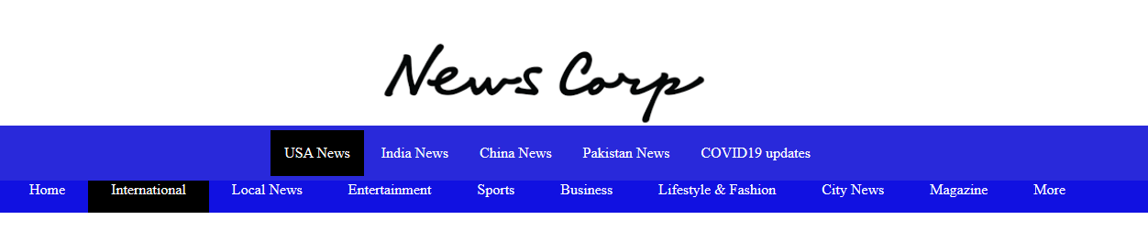

We created a header with the CSS which shows true style and elegance hence, justifies the design. we used a logo which is catchy and simple which attracts viewers’ attention and visual memory.

We created navigation tools with a drop-down menu for sub categories which further classifies and organizes the news website.

We tried to make everything as simple as possible to emulate the experience of reading an actual newspaper which makes it a digital newspaper.

Upper image is the exact illustration of the points described in this section.

**2.2 Details of the website**

**2.2.1 Slide show headlines**

We added a slide show of headlines at the top after header to attract viewers attention to specific important headlines that viewers would be interested in. it has a simple animation which justifies our aim of making a simplistic online newspaper.

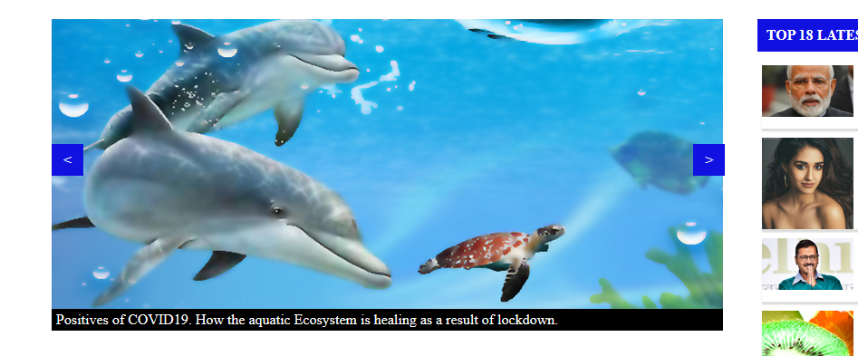

**2.2.2 News Sidebar and popular categories**

We created a sidebar with the top 18 news headlines which focuses readers attention to the trending news headlines regarding all fields. Business, lifestyle, fashion, Bollywood, politics. Each headline is accompanied by a photo having a direct relation to the headline which helps us understand the news clearly and makes it attractive.

We also created categories of international and business news as they are the most important news headlines which are mostly browsed by the active readers of newsletters. Which also provides ease to the reader and keeps them informed.

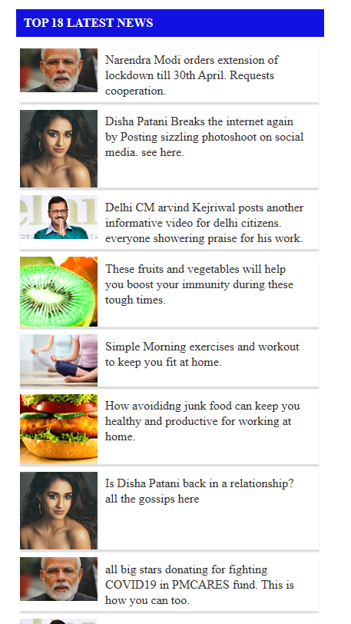

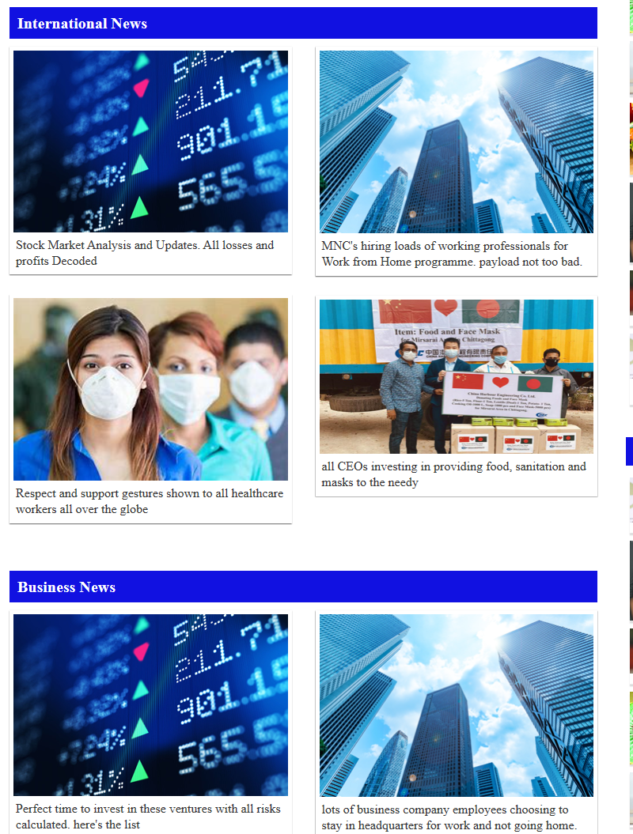

**2.2.3 Subscribers bar**

We created a subscribe us bar where the reader has to fill the email address which helps them to receive daily online newsletters on their email address which ensures the loyalty of our customers and it keeps them binded to us. It also saves the reader time and it is analogous to a news man bringing the newspaper to you at your home.



**2.2.4 Video Gallery**

We created a video gallery option, which is the feature which kicks our online newsletter way ahead of normal newsletters. This is the feature which takes the complete advantage of the features of the internet. We can have broadcast news, and recorded important news reports, footage of important news, highlights of sports which makes news reading a more immersive experience.

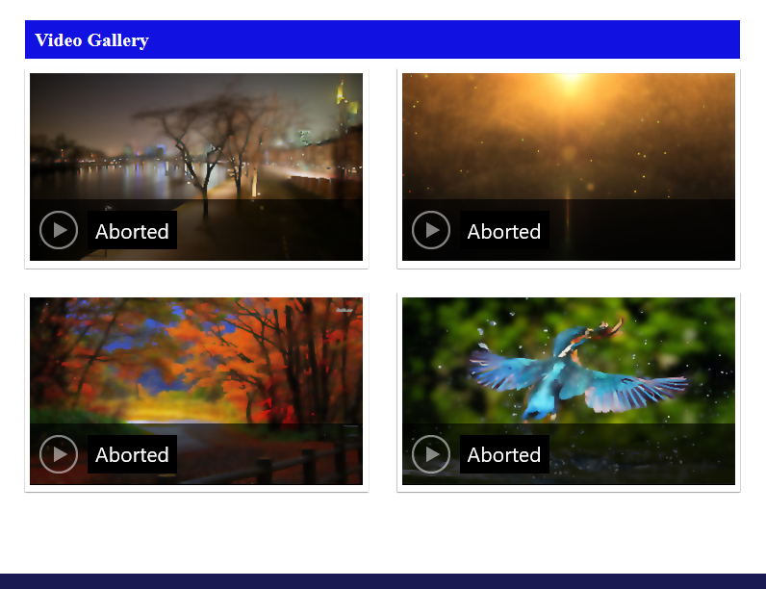

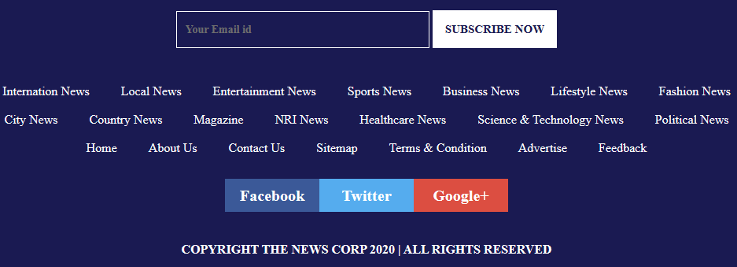

We also created social media links where our subscribers can join us for daily updates across all platforms available. We also added lots of sub divisions categories of news at the footer to make our news more personalized for the interests of the reader.

**Work Division**

All the designing work is done by an equal contribution from all the members of this group. We Sat together after classes and worked together using social media and created the website. The written work reports were written by Rahul Singh Raghav. This would not have been possible with the basic understanding of concepts provided to us by our teacher Dr. Dhanpratap Singh

**SWOT Analysis**

Strengths

* Implementation of layout
* Color combination
* Writing the demo content
* Designing

Weaknesses

* Adjusting the float
* Working with JavaScript

Opportunities

* To work and bend the designing ideas with help of CSS, HTML.
* Designing on our own.